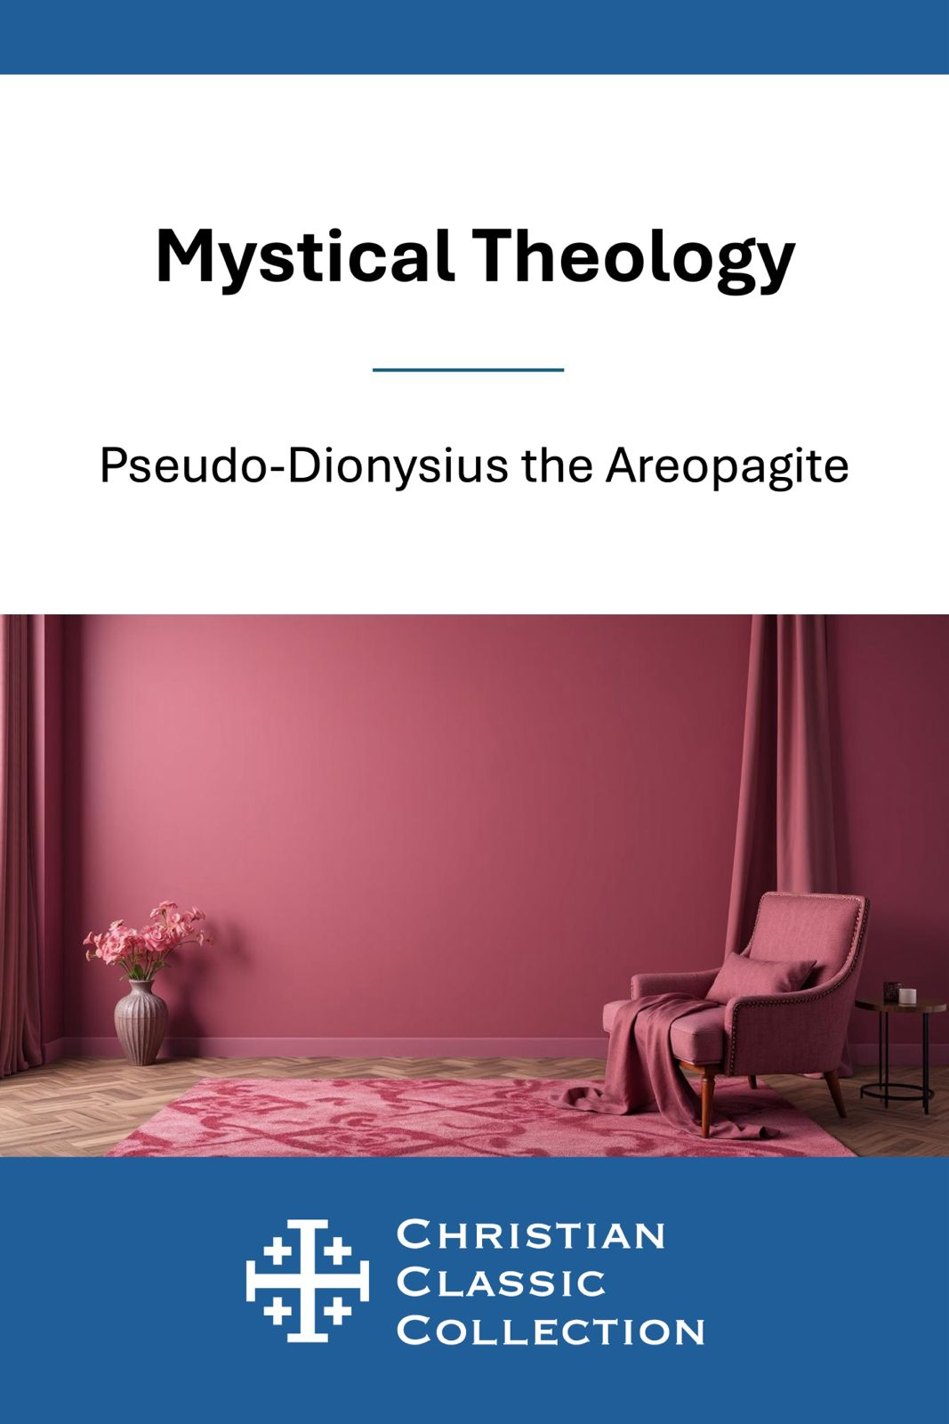


Copyright © 2025 by BSB Publishing LLC

Pseudo-Dionysius the Areopagite
Pseudo-Dionysius the Areopagite (late 5th – early 6th century) remains one of the most mysterious and luminous figures in Christian thought—a theologian cloaked in anonymity yet whose influence shines through the centuries. Writing under the name of Dionysius, the Athenian convert of St. Paul mentioned in Acts 17:34, he wove together biblical revelation, mystical theology, and Neoplatonic philosophy into a vision of divine transcendence that reshaped both Eastern and Western spirituality.
His small but profound corpus—The Divine Names, Mystical Theology, The Celestial Hierarchy, and The Ecclesiastical Hierarchy—presents God as beyond all words and concepts, known only through unknowing (via negativa). Pseudo-Dionysius described creation as a radiant hierarchy of beings, all reflecting and returning to the One who is beyond being itself. His language of light, ascent, and silence inspired mystics such as John of the Cross, Thomas Aquinas, and Maximus the Confessor.
Though his true identity remains hidden, his vision endures: a breathtaking call to approach God not with domination or certainty, but with awe, humility, and the burning love that draws the soul into divine mystery.

Introduction
Pseudo-Dionysius’s Mystical Theology is the bravest little book in Christian thought: a guide to knowing God by unknowing. In a handful of pages, the Areopagite leads us, with Moses, into the cloud on Sinai where speech fails and love listens. Having learned to name God in The Divine Names, we now learn to “unsay”: to lay aside even our holiest concepts so that the superabundant Light can meet us as a darkness to our minds.
This is not nihilism; it is reverence. Dionysius teaches that every true affirmation is good—and also limited. Step by step he invites us to pass beyond images, beyond reason’s ladders, into simple, wordless prayer where the soul is joined to the One who is beyond being and goodness. In a noisy age, his counsel is startlingly practical: be silent, be simple, let desire be purified, and let God be God. Read slowly. Let the sentences thin into prayer. By the end you’ll find that unknowing has become adoration—and that wonder is the truest theology.

CHAPTER I
What is the Divine Darkness?
Supernal Triad, Deity above all essence, knowledge and goodness; Guide of Christians to Divine Wisdom; direct our path to the ultimate summit of your mystical knowledge, most incomprehensible, most luminous and most exalted, where the pure, absolute and immutable mysteries of theology are veiled in the dazzling obscurity of the secret Silence, outshining all brilliance with the intensity of their Darkness, and surcharging our blinded intellects with the utterly impalpable and invisible fairness of glories surpassing all beauty.
Let this be my prayer; but do, dear Timothy, in the diligent exercise of mystical contemplation, leave behind the senses and the operations of the intellect, and all things sensible and intellectual, and all things in the world of being and nonbeing, that you may arise by unknowing towards the union, as far as is attainable, with it that transcends all being and all knowledge.(1) For by the unceasing and absolute renunciation of yourself and of all things you may be borne on high, through pure and entire self-abnegation, into the superessential Radiance of the Divine Darkness.(2)
But these things are not to be disclosed to the uninitiated, by whom I mean those attached to the objects of human thought, and who believe there is no superessential Reality beyond, and who imagine that by their own understanding they know it that has made Darkness Its secret place. And if the principles of the divine Mysteries are beyond the understanding of these, what is to be said of others still more incapable thereof, who describe the transcendental First Cause of all by characteristics drawn from the lowest order of beings, while they deny that it is in any way above the images which they fashion after various designs; whereas they should affirm that, while it possesses all the positive attributes of the universe (being the Universal Cause) yet, in a more strict sense, it does not possess them, since it transcends them all; wherefore there is no contradiction between the affirmations and the negations, inasmuch as it infinitely precedes all conceptions of deprivation, being beyond all positive and negative distinctions.
Thus the blessed Bartholomew asserts that the divine science is both vast and minute, and that the Gospel is great and broad, yet concise and short; signifying by this, that the beneficent Cause of all is most eloquent, yet utters few words, or rather is altogether silent, as having neither (human) speech nor (human) understanding, because it is super-essentially exalted above created things, and reveals itself in Its naked Truth to those alone who pass beyond all that is pure or impure, and ascend above the topmost altitudes of holy things, and who, leaving behind them all divine light and sound and heavenly utterances, plunge into the Darkness where truly dwells, as the Oracles declare, that ONE who is beyond all.(3)
It was not without reason that the blessed Moses was commanded first to purify himself and them to separate himself from those who had not undergone purifcation; and after the entire purification heard many trumpets and saw many lights streaming forth with pure and manifold rays; and that he was thereafter separated from the multitude, with the elect priests, and pressed forward to the summit of the divine ascent. Nevertheless, he did not attain to the Presence of God itself; he saw not it (for it cannot be looked upon) but the Place where it dwells. And this I take to signify that the divinest and highest things seen by the eyes or contemplated by the mind are but the symbolical expressions of those that are immediately beneath it that is above all. Through these, Its incomprehensible Presence is manifested upon those heights of Its Holy Places; that then It breaks forth, even from that which is seen and that which sees, and plunges the mystic into the Darkness of Unknowing, whence all perfection of understanding is excluded, and he is enwrapped in that which is altogether intangible, wholly absorbed in it that is beyond all, and in none else (whether himself or another); and through the inactivity of all his reasoning powers is united by his highest faculty to it that is wholly unknowable; thus by knowing nothing he knows That which is beyond his knowledge. (4)

CHAPTER II
The necessity of being united with and of rendering praise to it that is the Cause of all and above all.
We pray that we may come unto this Darkness which is beyond light, and, without seeing and without knowing, to see and to know that which is above vision and knowledge through the realization that by not-seeing and by unknowing we attain to true vision and knowledge; and thus praise, superessentially, it that is superessential, by the transcendence of all things; even as those who, carving a statue out of marble, abstract or remove all the surrounding material that hinders the vision which the marble conceals and, by that abstraction, bring to light the hidden beauty.(5)
It is necessary to distinguish this negative method of abstraction from the positive method of affirmation, in which we deal with the Divine Attributes. For with these latter we begin with the universal and primary, and pass through the intermediate and secondary to the particular and ultimate attributes; but now we ascend from the particular to the universal conceptions, abstracting all attributes in order that, without veil, we may know that Unknowing which is enshrouded under all that is known and all that can be known, and that we may begin to contemplate the superessential Darkness which is hidden by all the light that is in existing things.

CHAPTER III
What are the affirmations and the negations concerning God?
In the Theological Outlines (6) we have set forth the principal affirmative expressions concerning God, and have shown in what sense God’s Holy Nature is One, and in what sense Three; what is within It which is called Paternity, what Filiation, and what is signified by the name Spirit; how from the uncreated and indivisible Good, the blessed and perfect Rays of its Goodness proceed, and yet abide immutably one both within their Origin and within themselves and each other, co-eternal with the act by which they spring from it; how the superessential Jesus enters in essential state in which the truths of human nature meet; and other matters made known by the Oracles are expounded in the same place.
Again, in the treatise on Divine Names, we have considered the meaning, as concerning God, of the titles of Good, of Being, of Life, of Wisdom, of Power, and of such other names as are applied to it; further, in Symbolical Theology we have considered what are the metaphorical titles drawn from the world of sense and applied to the nature of God; what is meant by the material and intellectual images we form of it, or the functions and instruments of activity attributed to it; what are the places where it dwells and the raiment in which it is adorned; what is meant by God’s anger, grief and indignation, or the divine inebriation; what is meant by God’s oaths and threats, by Its slumber and waking; and all sacred and symbolical representations. And it will be observed how far more copious and diffused are the last terms than the first, for the theological doctrine and the exposition of the Divine Names are necessarily more brief than the Symbolical Theology.
For the higher we soar in contemplation the more limited become our expressions of that which is purely intelligible; even as now, when plunging into the Darkness that is above the intellect, we pass not merely into brevity of speech, but even into absolute silence of thoughts and of words. Thus, in the former discourse, our contemplations descended from the highest to the lowest, embracing an ever-widening number of conceptions, which increased at each stage of the descent; but in the present discourse we mount upwards from below to that which is the highest, and, according to the degree of transcendence, so our speech is restrained until, the entire ascent being accomplished, we become wholly voiceless, inasmuch as we are absorbed in it that is totally ineffable. But why, you will ask, ‘does the affirmative method begin from the highest attributions, and the negative method with the lowest abstractions?’ The reason is because, when affirming the subsistence of That which transcends all affirmation, we necessarily start from the attributes most closely related to It and upon which the remaining affirmations depend; but when pursuing the negative method to reach That which is beyond all abstraction, we must begin by applying our negations to things which are most remote from It.
For is it not more true to affirm that God is Life and Goodness than that God is air or stone; and must we not deny to God more emphatically the attributes of inebriation and wrath than the applications of human speech and thought?

CHAPTER IV
That it that is the pre-eminent Cause of all things sensibly perceived is not itself any of those things.
We therefore maintain that the universal and transcendent Cause of all things is neither without being nor without life, nor without reason or intelligence; nor is it a body, nor has it form or shape, quality, quantity or weight; nor has it any localized, visible or tangible existence; it is not sensible or perceptible; nor is it subject to any disorder or inordination nor influenced by any earthly passion; neither is it rendered impotent through the effects of material causes and events; it needs no light; it suffers no change, corruption, division, privation or flux; none of these things can either be identified with or attributed unto it.

CHAPTER V
That it that is the pre-eminent Cause of all things intelligibly perceived is not itself any of those things.
Again, ascending yet higher, we maintain that it is neither soul nor intellect; nor has it imagination, opinion reason or understanding; nor can it be expressed or conceived, since it is neither number nor order; nor greatness nor smallness; nor equality nor inequality; nor similarity nor dissimilarity; neither is it standing, nor moving, nor at rest; neither has it power nor is power, nor is light; neither does it live nor is it life; neither is it essence, nor eternity nor time; nor is it subject to intelligible contact; nor is it science nor truth, nor kingship nor wisdom; neither one nor oneness, nor godhead nor goodness; nor is it spirit according to our understanding, nor filiation, nor paternity; nor anything else known to us or to any other beings of the things that are or the things that are not; neither does anything that is know it as it is; nor does it know existing things according to existing knowledge; neither can the reason attain to it, nor name it, nor know it; neither is it darkness nor light, nor the false nor the true; nor can any affirmation or negation be applied to it, for although we may affirm or deny the things below it, we can neither affirm nor deny it, inasmuch as the all-perfect and unique Cause of all things transcends all affirmation, and the simple pre-eminence of Its absolute nature is outside of every negation- free from every limitation and beyond them all.

NOTES
(1) Unknowing, or agnosia, is not ignorance or nescience as ordinarily understood, but rather the realization that no finite knowledge can fully know the Infinite One, and that therefore it is only truly to be approached by agnosia, or by that which is beyond and above knowledge. There are two main kinds of darkness: the subdarkness and the super-darkness, between which lies, as it were, an octave of light. But the nether-darkness and the Divine Darkness are not the same darkness, for the former is absence of light, while the latter is excess of light. The one symbolizes mere ignorance, and the other a transcendent unknowing – a superknowledge not obtained by means of the discursive reason.
(2) ‘Of the First Principle,’ says Damascius, ‘the ancient Egyptians said nothing, but celebrated it as a Darkness beyond all intellectual or spiritual perception – a Thrice-unknown Darkness.’ This is for ever about the Pavilions of that great Light Unapproachable. It is caused by the superabundance of Light and not by the absence of lumination: it is ‘a deep but dazzling Darkness’ (Henry Vaughan). ‘The light shineth in the darkness’ (St. John, 1, 5). ‘In Thy light we shall see light’ (Psalm 36, 9).
(3) St. John of the Cross, for instance, wrote of other kinds of darkness; for example, the darkness of the night of purgation, and the dark night of the soul, but the Divine Darkness is in a different category from these.
(4) Particularly important here is the concept of beyond-being, the recognition that what is known in the unknowing is beyond the realm of being and cannot be adequately described, although negation comes closer than affirmation.
(5) Compare the well-known analogy of Plotinus: ‘Withdraw into yourself and look; and if you do not find yourself beautiful as yet, do as does the sculptor of a statue … cut away all that is excessive, straighten all that is crooked, bring light to all that is shadowed … do not cease until there shall shine out on you the Godlike Splendour of Beauty; until you see temperance surely established in the stainless shrine (Ennead, 1, 6, 9).
(6) Dionysius refers to several of his treatises, but besides the Mystical Theology the other extant works of his are Divine Names, The Celestial Hierarchies, Ecclesiastical Hierarchy, and various epistles. See The Complete Works, Colm Luibheid, trs., (Paulist Press: 1987), now, unfortunately, out of print.

